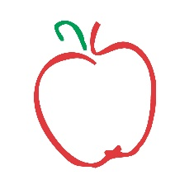

Pick-your-own berries at White House Fruit Farm
Fields are located at additional property owned by WHFF :
8652 Leffingwell Road Canfield, OH 44406
- Pick-your-own strawberry Hours: Will be determined daily depending on crop
Monday-Friday 8:00-2:00, Saturday 8:00-4:00, Closed Sunday
- If you are not feeling well, have a fever, are sneezing or coughing, or have any health issues, please stay home until symptoms have passed
- Wash your hands and sanitize before picking berries
- Clean masks and gloves are recommended (please provide your own)
- Please maintain a distance of at least 6 feet between other parties at all times
- Follow all instructions given by our staff members
- Be prepared for a walk of 5-10 minutes to the designated field and back
- All fruit must be picked into our new containers. No used containers please!
- Any fruit you touch must go into your picking container-do not throw any fruit on the ground
- Parents are responsible for their children at all times
- Only pick from the areas/rows you are assigned
- Berries must be paid for before placing into your vehicle
- Cash only please
- Pets are not permitted in the field
- No smoking on our property at any time
- Last entrance into field is 30 minutes prior to our closing time
- We reserve the right to close the fields for picking at any time due to weather, lack of ripe fruit, non-compliance of our policies, or any other unforeseen reason
- Be aware that picking conditions may change daily due to weather, heavy picking, or other reasons. Please stay tuned to our social media for updates or call our Market for voicemail updates

