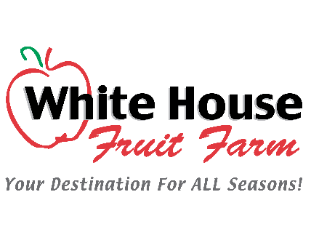

Greetings Farm Friends-

The safety of our visitors and team members while at our farm is always our highest priority. It is important to us that we openly communicate our commitment to maintaining a healthy environment for all your visits to White House Fruit Farm. We are continually following public health recommendations and monitoring the COVID-19 situation closely.

The Market will continue to be OPEN daily, Monday through Saturday, 9-5 and Sunday 12-5.

As a precaution, we have decided to CANCEL our annual White House Weekend this year. We feel it is best to encourage social distancing while on the farm or in the Market and not draw large crowds together during this crisis. We have made no decisions about future events at this time.

We have always, and will continue to, follow a strong Food Safety program, including sanitizing counters, credit card terminals, and door handles. As recommended, hand washing using soap and water, is the #1 best way to prevent the catching/spreading of viruses and bacteria. Guests are also encouraged to bring their own hand-sanitizer and tissues. We strongly recommend that any employees or guests that are experiencing any symptoms including coughing, fever, shortness of breath, etc, remain at home.

As always, we are here via email at admin@whitehousefruitfarm.com , by phone at 330-533-4161
or in person to answer any questions you have regarding your visit to the farm. This information is posted on our website, including much more on the FAQ page.

Sincerely,
The Hull Family
And Staff at White House

